MONDAY  14/4/25 | TUESDAY  15/4/25 | WEDNESDAY  16/4/25 | THURSDAY  17/4/25 | FRIDAY  18/4/25
OBSTACLE COURSE  EXTREME FUN RUN  In the Gym  10.00am – 3.30pm  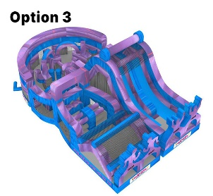  ART/CRAFT  Easter Crowns  Sleeping bunny 3D art  COOKING  Jelly Cookies   | EXCURSION  Tailem Town  Pioneer Village  Journey Back in Time, Explore the village to see what life was like for the settlers of South Australia from 1860 - 1960  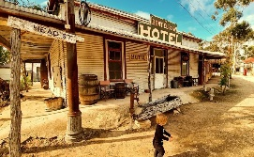  9.00am – 4.00pm  AFTERNOON MOVIE  In the Gym  Back to the outback | Easter Day    Minute to win it Easter Games  COOKING  Hot Cross Buns  Marshmallow  AFTERNOON MOVIE  In the Gym  HOP  ART/CRAFT  Rabbit Origami  3D Easter card    EASTER EGG HUNT | EXCURSION  Hoyts Cinema  Arndale  Snow White  9.00am – 1.00pm    COOKING  Apple Muffins  ART/CRAFT  Snow white & the 7 dwarfs | PUBLIC  HOLIDAY  GOOD FRIDAY    The Easter bunny is almost here…
Snack: Sandwiches | Snack: Tin Fruit &  Yoghurt | Snack: Pizza | Snack: Crackers, Salad & Dip platter | Snack:
MONDAY  21/4/25 | TUESDAY  22/4/25 | WEDNESDAY  23/4/25 | THURSDAY  24/4/25 | FRIDAY  25/4/25
PUBLIC  HOLIDAY  EASTER  MONDAY   | EXCURSION  Hoyts Cinema  Arndale  A Minecraft Movie  9.00am – 1.00pm    Minecraft Word Search  ART/CRAFT  Paint by Number  COOKING  Minecraft rice krispies  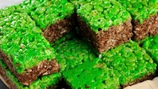 |     EARTH DAY  YOGA  SCIENCE  Earth day Slime  Grass Heads  Acid Rain  Plastic Milk  ART/CRAFT  Earth Magnets  Painted Rocks      COOKING  Butterfly fruit cookies  Lady Bug crackers  Earth Day recycle Game  Earth Day Escape Room | EXCURSION  Bounce  Greenacres    10.00am – 12.00pm  JUMP, BOUNCE, FLY  COOKING  Lamington Wreath  ART/CRAFT  Anzac wreaths  PARACHUTE GAMES   | PUBLIC  HOLIDAY  ANZAC DAY  
Snack | Snack: Crackers, Salad & Dip platter | Snack: Burrito Bowls | Snack: Crackers, Salad & Dip platter | Snack:
PROSPECT NORTH APRIL VACATION CARE 2024
Booking need to be made by March 28th. Bookings made after this date may not be accepted
Due to unforeseen circumstances the program may be subject to change

